Identical Components

Definition
# Source: AI Source: Provided by: [Data Path: Persons Table -> ID Column: 1, Name_En Column: Motasem Essam] -> From: [ChatGPT] on [7/25/2026]
Identical-component composite solids are composite three-dimensional solids formed by joining two or more components that have exactly the same geometric shape and dimensions.
Each component has the same:
- Geometric shape.
- Length, width, and height, where applicable.
- Radius and height, for cylindrical components.
- Base dimensions and height, for pyramids and cones.
- Volume and surface area.
The components may be arranged linearly, vertically, horizontally, in layers, in grids, radially, or in other configurations.

Simple Definition
# Source: AI Source: Provided by: [Data Path: Persons Table -> ID Column: 1, Name_En Column: Motasem Essam] -> From: [ChatGPT] on [7/25/2026]
An identical-component composite solid is a larger solid made by joining multiple copies of the same three-dimensional solid, with every copy having equal dimensions.
For example, joining four identical cubes creates a composite solid consisting of four equal-sized cubic components.

Geometric Representation
# Source: AI Source: Provided by: [Data Path: Persons Table -> ID Column: 1, Name_En Column: Motasem Essam] -> From: [ChatGPT] on [7/25/2026]
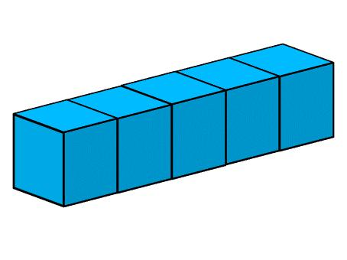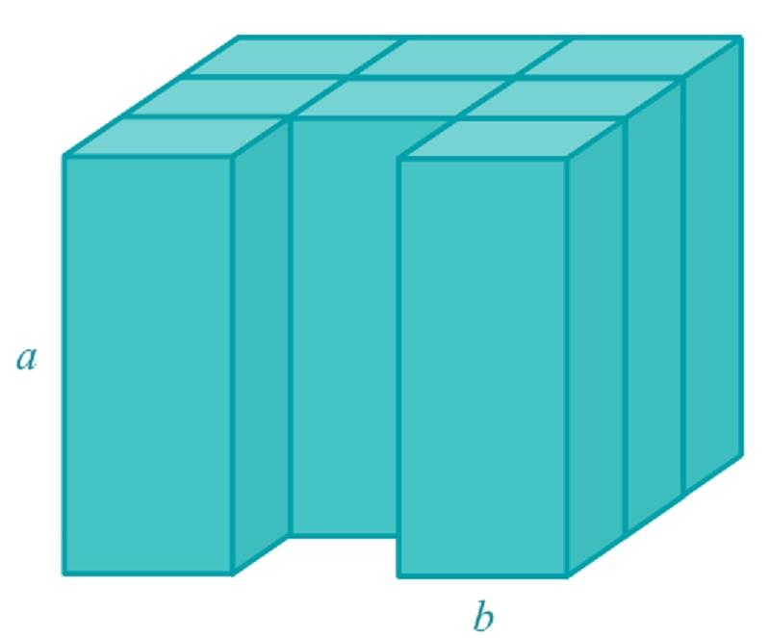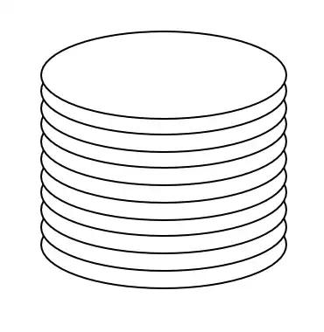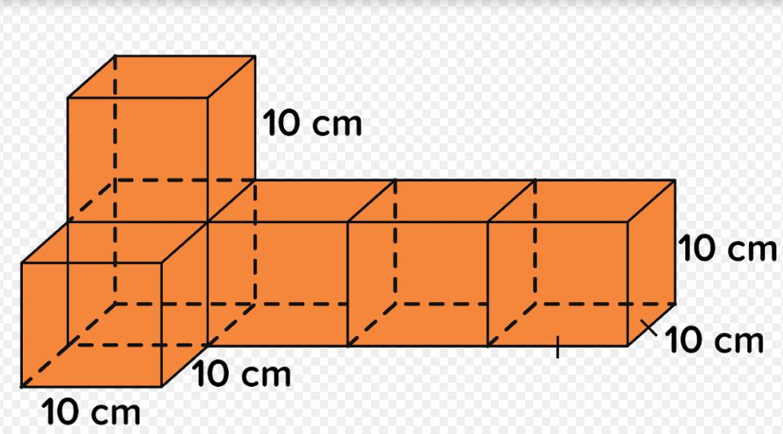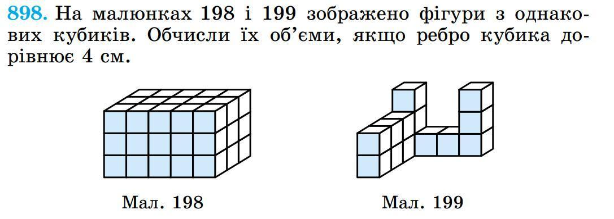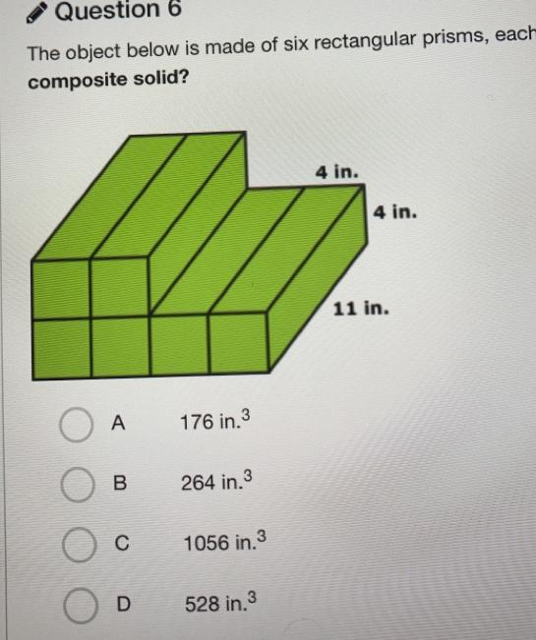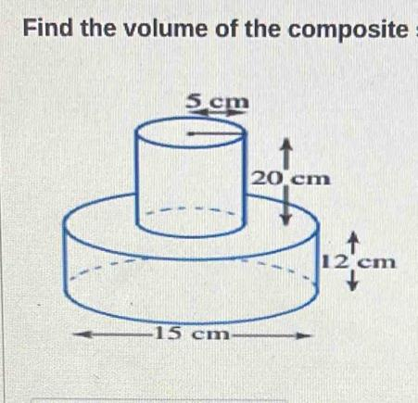
The examples illustrate different arrangements of components while preserving identical dimensions within each composite solid.

Main Classification
# Source: AI Source: Provided by: [Data Path: Persons Table -> ID Column: 1, Name_En Column: Motasem Essam] -> From: [ChatGPT] on [7/25/2026]
Identical-component composite solids can be classified according to the geometric shape of their repeated components.

Cube-Based Identical Components
# Source: AI Source: Provided by: [Data Path: Persons Table -> ID Column: 1, Name_En Column: Motasem Essam] -> From: [ChatGPT] on [7/25/2026]
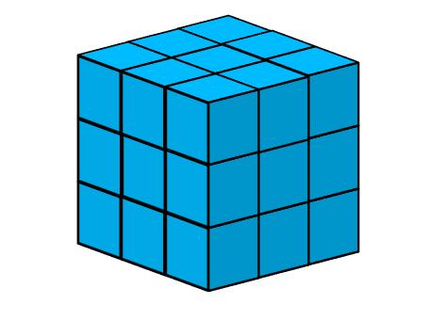
- Every component is a cube.
- All edges have the same length.
- All components have equal volume and surface area.
For a cube with side length $s$:
$$V_{cube}=s^{3}$$
$${SA}_{cube}=6s^{2}$$

Rectangular Prism-Based Identical Components
# Source: AI Source: Provided by: [Data Path: Persons Table -> ID Column: 1, Name_En Column: Motasem Essam] -> From: [ChatGPT] on [7/25/2026]
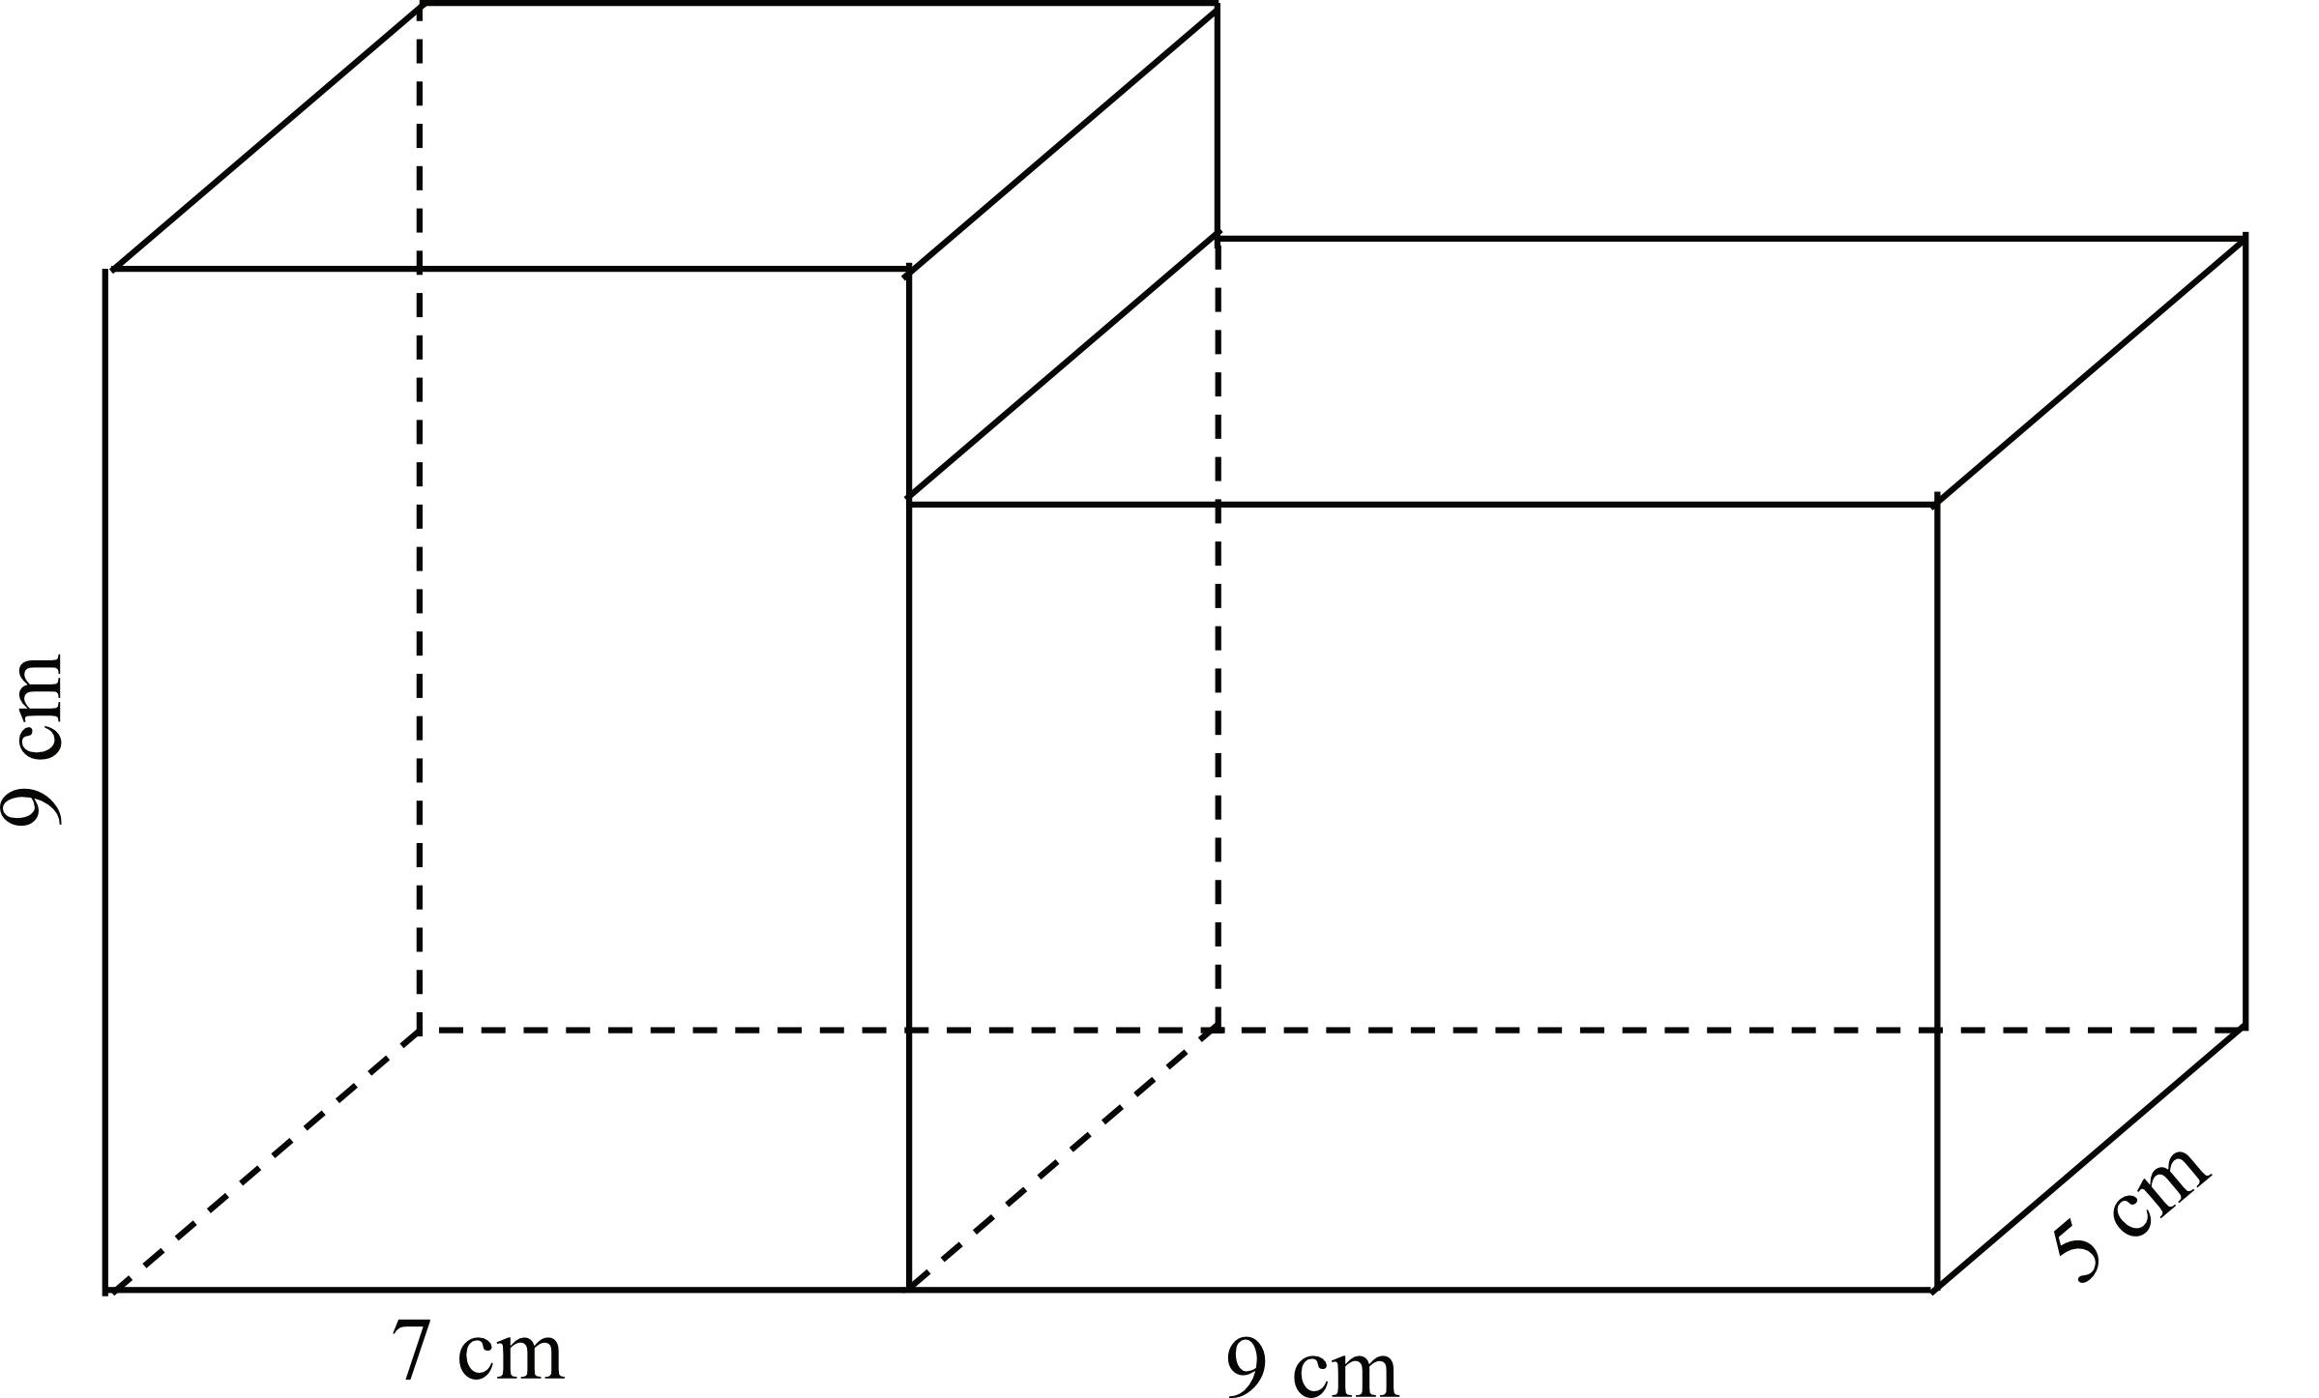
- Every component is a rectangular prism.
- Corresponding lengths, widths, and heights are equal.
- All components have equal volume and surface area.
For dimensions $l,w,h$:
$$V_{prism}=lwh$$
$${SA}_{prism}=2(lw+lh+wh)$$

Cylinder-Based Identical Components
# Source: AI Source: Provided by: [Data Path: Persons Table -> ID Column: 1, Name_En Column: Motasem Essam] -> From: [ChatGPT] on [7/25/2026]
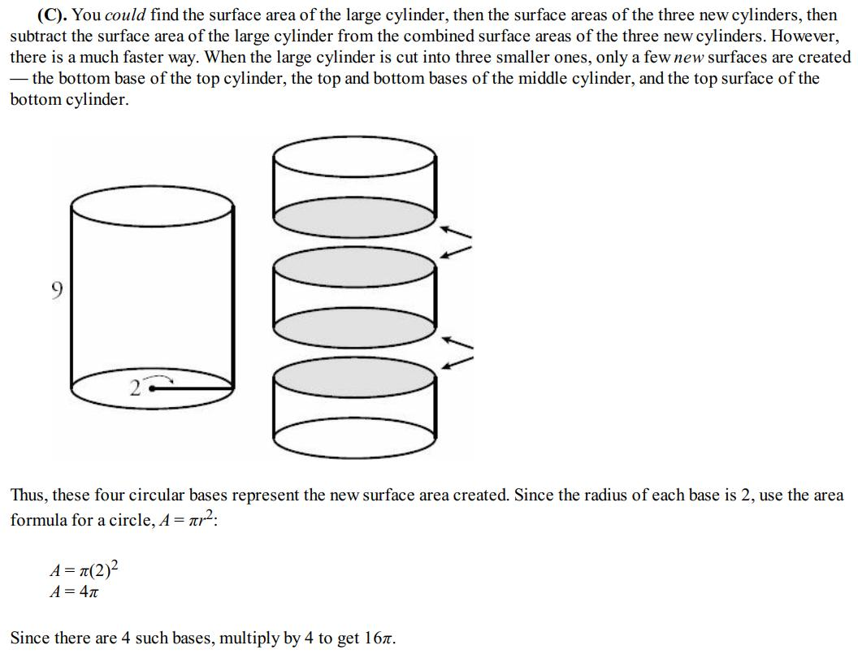
- Every component is a cylinder.
- All cylinders have equal radii and heights.
- Their axes may be aligned or oriented differently.
For radius $r$ and height $h$:
$$V_{cylinder}=πr^{2}h$$
$${SA}_{cylinder}=2πr(r+h)$$

Cone-Based Identical Components
# Source: AI Source: Provided by: [Data Path: Persons Table -> ID Column: 1, Name_En Column: Motasem Essam] -> From: [ChatGPT] on [7/25/2026]
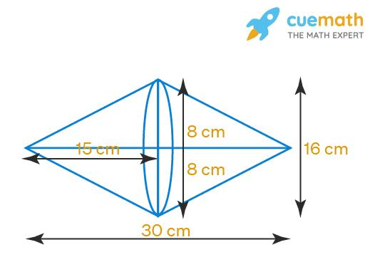
- Every component is a cone.
- All cones have equal base radii and heights.
- Their orientations and positions may vary.
For radius $r$ and perpendicular height $h$:
$$V_{cone}=\frac{1}{3}πr^{2}h$$

Pyramid-Based Identical Components
# Source: AI Source: Provided by: [Data Path: Persons Table -> ID Column: 1, Name_En Column: Motasem Essam] -> From: [ChatGPT] on [7/25/2026]
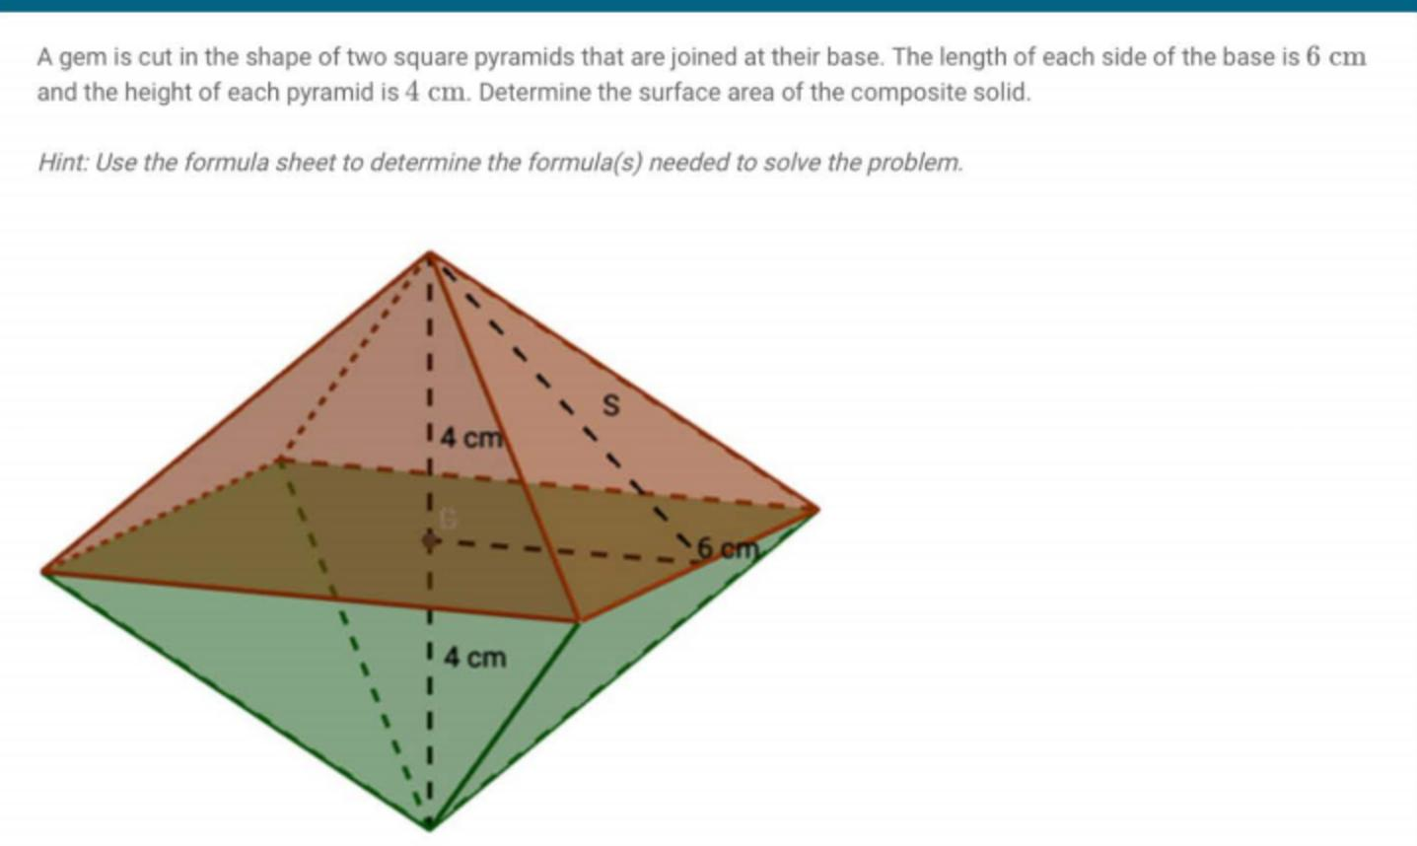
- Every component is a pyramid of the same type.
- Corresponding base dimensions and perpendicular heights are equal.
- Components may have different orientations while retaining identical dimensions.
For a pyramid with base area $B$ and perpendicular height $h$:
$$V_{pyramid}=\frac{1}{3}Bh$$

Sphere-Based Identical Components
# Source: AI Source: Provided by: [Data Path: Persons Table -> ID Column: 1, Name_En Column: Motasem Essam] -> From: [ChatGPT] on [7/25/2026]
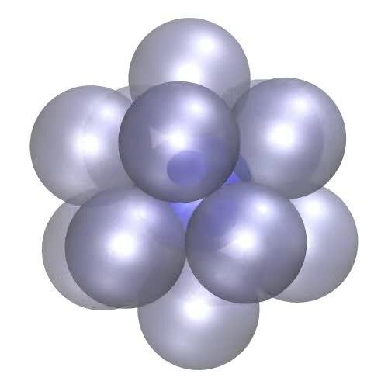
- Every component is a sphere.
- All spheres have the same radius and diameter.
- They may be arranged in rows, layers, clusters, or circular patterns.
For radius $r$:
$$V_{sphere}=\frac{4}{3}πr^{3}$$
$${SA}_{sphere}=4πr^{2}$$

Hemisphere-Based Identical Components
# Source: AI Source: Provided by: [Data Path: Persons Table -> ID Column: 1, Name_En Column: Motasem Essam] -> From: [ChatGPT] on [7/25/2026]
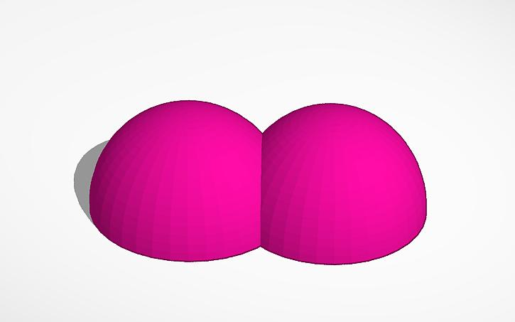
- Every component is a hemisphere.
- All hemispheres have equal radii.
- They may be joined through their flat circular bases or other contact regions.
For radius $r$:
$$V_{hemisphere}=\frac{2}{3}πr^{3}$$
$${SA}_{hemisphere}=3πr^{2}$$
Here, the surface area includes both the curved surface and the flat circular base.

Classification by Component Arrangement
# Source: AI Source: Provided by: [Data Path: Persons Table -> ID Column: 1, Name_En Column: Motasem Essam] -> From: [ChatGPT] on [7/25/2026]
Identical components can be arranged in different configurations.
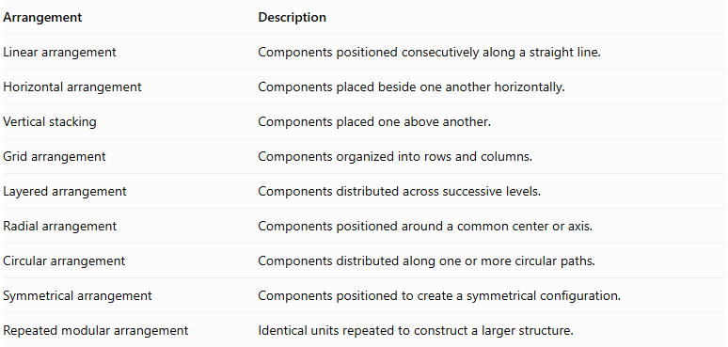
Arrangement | Description
Linear arrangement | Components positioned consecutively along a straight line.
Horizontal arrangement | Components placed beside one another horizontally.
Vertical stacking | Components placed one above another.
Grid arrangement | Components organized into rows and columns.
Layered arrangement | Components distributed across successive levels.
Radial arrangement | Components positioned around a common center or axis.
Circular arrangement | Components distributed along one or more circular paths.
Symmetrical arrangement | Components positioned to create a symmetrical configuration.
Repeated modular arrangement | Identical units repeated to construct a larger structure.

Classification by Number of Components
# Source: AI Source: Provided by: [Data Path: Persons Table -> ID Column: 1, Name_En Column: Motasem Essam] -> From: [ChatGPT] on [7/25/2026]
Identical-component composite solids can also be classified by the number of repeated components.
- Two-component composite solid: Formed from two identical components.
- Three-component composite solid: Formed from three identical components.
- Four-component composite solid: Formed from four identical components.
- Five-component composite solid: Formed from five identical components.
- Multiple-component composite solid: Formed from six or more identical components.
For $n$ identical components:
$$n=2,3,4,…$$

Mathematical Properties and Formulas

Total Volume
# Source: AI Source: Provided by: [Data Path: Persons Table -> ID Column: 1, Name_En Column: Motasem Essam] -> From: [ChatGPT] on [7/25/2026]
When the components do not overlap internally, the total volume is the sum of their individual volumes.
$$\boxed{V_{total}={nV}_{c}}$$
Where:
- $n$ = Number of components.
- $V_{c}$ = Volume of one component.

Total Surface Area
# Source: AI Source: Provided by: [Data Path: Persons Table -> ID Column: 1, Name_En Column: Motasem Essam] -> From: [ChatGPT] on [7/25/2026]
The total external surface area is not necessarily equal to the sum of the individual surface areas because joined regions become internal and are no longer exposed.
For components joined through complete matching planar faces:
$$\boxed{{SA}_{total}={nSA}_{c}-2{kA}_{j}}$$
Where:
- ${SA}_{c}$ = Surface area of one component.
- $k$ = Number of shared face pairs.
- $A_{j}$ = Area of one shared joining face.
This formula assumes that each shared face pair is counted once and that the joining faces are completely hidden.
For partial contact or curved intersections, the actual exposed surfaces must be calculated separately.

Total Mass
# Source: AI Source: Provided by: [Data Path: Persons Table -> ID Column: 1, Name_En Column: Motasem Essam] -> From: [ChatGPT] on [7/25/2026]
If all components have the same material density:
$$\boxed{M_{total}={nM}_{c}}$$
Where $M_{c}$ is the mass of one component.

Total Number of Components
# Source: AI Source: Provided by: [Data Path: Persons Table -> ID Column: 1, Name_En Column: Motasem Essam] -> From: [ChatGPT] on [7/25/2026]
For a regular grid:
$$N=R×C×L$$
Where:
- $R$ = Number of rows.
- $C$ = Number of columns.
- $L$ = Number of layers.

Worked Examples

Example 1: Four Identical Cubes Joined in a Row
# Source: AI Source: Provided by: [Data Path: Persons Table -> ID Column: 1, Name_En Column: Motasem Essam] -> From: [ChatGPT] on [7/25/2026]
Given:
- Number of cubes: $n=4$.
- Side length of each cube: $s=3 cm$.
- All cubes are joined face-to-face in a straight row.
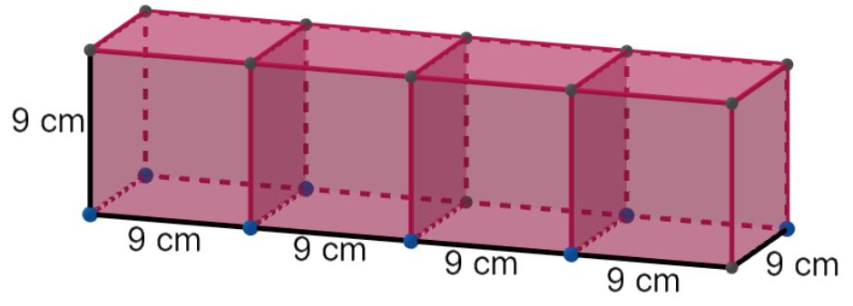
Step 1: Calculate the volume of one cube.
$$V_{c}=s^{3}=3^{3}=27{ cm}^{3}$$
Step 2: Calculate the total volume.
$$V_{total}=4×27$$
$$\boxed{V_{total}=108{ cm}^{3}}$$
Step 3: Calculate the total external surface area.
Each cube has six faces, and the four cubes create three shared face pairs.
$${SA}_{c}=6(3^{2})=54{ cm}^{2}$$
$${SA}_{total}=4(54)-2(3)(3^{2})$$
$$=216-54$$
$$\boxed{{SA}_{total}=162{ cm}^{2}}$$
Step 4: Calculate the overall dimensions.
$$L=4(3)=12 cm$$
$$W=3 cm, H=3 cm$$
The resulting composite solid has dimensions $12×3×3 cm$.

Example 2: Three Identical Cylinders Stacked Vertically
# Source: AI Source: Provided by: [Data Path: Persons Table -> ID Column: 1, Name_En Column: Motasem Essam] -> From: [ChatGPT] on [7/25/2026]
Given:
- Number of cylinders: $n=3$.
- Radius: $r=2 cm$.
- Height of each cylinder: $h=4 cm$.
- All cylinders are coaxial and joined through their complete circular bases.
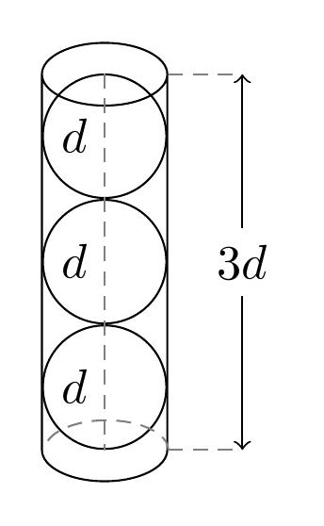
Step 1: Calculate the volume of one cylinder.
$$V_{c}=πr^{2}h$$
$$V_{c}=π(2)^{2}(4)=16π$$
Step 2: Calculate the total volume.
$$V_{total}=3(16π)$$
$$\boxed{V_{total}=48π≈150.80{ cm}^{3}}$$
Step 3: Calculate the total external surface area.
The three cylinders have two shared circular interfaces.
$${SA}_{c}=2πr(r+h)$$
$${SA}_{c}=2π(2)(2+4)=24π$$
$${SA}_{total}=3(24π)-2(2πr^{2})$$
$$=72π-16π$$
$$\boxed{{SA}_{total}=56π≈175.93{ cm}^{2}}$$
Step 4: Calculate the overall height.
$$H=3(4)$$
$$\boxed{H=12 cm}$$

Important Characteristics
# Source: AI Source: Provided by: [Data Path: Persons Table -> ID Column: 1, Name_En Column: Motasem Essam] -> From: [ChatGPT] on [7/25/2026]
- Equal dimensions: All components have exactly the same dimensions.
- Same geometric type: Every component belongs to the same geometric solid category.
- Equal individual volume: Each component has the same volume.
- Equal individual surface area: Each component has the same total surface area.
- Flexible arrangement: Components can be arranged in multiple configurations.
- Scalable structure: Additional identical components can be added while preserving the component dimensions.
- Variable external surface area: The final external surface area depends on the number and location of joining regions.
- Consistent material properties: If made from the same material, all components have equal density and mass.

Comparison with Other Component-Dimension Classifications
# Source: AI Source: Provided by: [Data Path: Persons Table -> ID Column: 1, Name_En Column: Motasem Essam] -> From: [ChatGPT] on [7/25/2026]
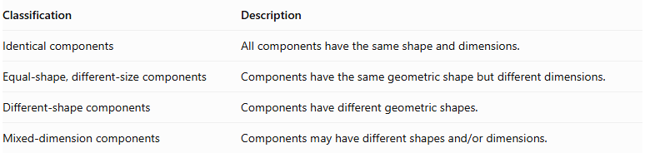
Classification | Description
Identical components | All components have the same shape and dimensions.
Equal-shape, different-size components | Components have the same geometric shape but different dimensions.
Different-shape components | Components have different geometric shapes.
Mixed-dimension components | $$Componentsmayhavedifferentshapesand/ordimensions.$$
Important distinction: Identical components must match in both shape and dimensions. Two cubes with different side lengths are not identical components, even though they belong to the same geometric category.

Applications
# Source: AI Source: Provided by: [Data Path: Persons Table -> ID Column: 1, Name_En Column: Motasem Essam] -> From: [ChatGPT] on [7/25/2026]
- Architecture: Repeated identical structural blocks and modular building units.
- Construction: Concrete blocks, bricks, and prefabricated components.
- Manufacturing: Products assembled from identical manufactured parts.
- Packaging: Arrangements of identical boxes or containers.
- Mechanical engineering: Assemblies using repeated identical cylindrical or other geometric parts.
- Mathematics: Problems involving volume, surface area, symmetry, and spatial arrangements.

Key Points
# Source: AI Source: Provided by: [Data Path: Persons Table -> ID Column: 1, Name_En Column: Motasem Essam] -> From: [ChatGPT] on [7/25/2026]
- Identical-component composite solids consist of two or more components with the same shape and dimensions.
- Components can be cubes, rectangular prisms, cylinders, cones, pyramids, spheres, or hemispheres.
- The total volume is $n$ times the volume of one component when there is no internal overlap.
- The external surface area depends on the joining configuration.
- Identical components can form linear, stacked, grid, radial, circular, and other arrangements.
- Equal shape alone does not guarantee identical components; their dimensions must also be equal.

Conclusion
# Source: AI Source: Provided by: [Data Path: Persons Table -> ID Column: 1, Name_En Column: Motasem Essam] -> From: [ChatGPT] on [7/25/2026]
Identical-component composite solids are formed by combining multiple copies of the same geometric solid, with every component having equal dimensions. This classification focuses on the dimensional equality of the components rather than their spatial arrangement. It provides a useful foundation for studying repeated structures, modular solids, and more complex composite geometric objects.

